**Raseiniai, the home town of the Komisaruk family, Sources**

(Chaim Freedman /09/2020)

The study of activities of the Komisaruk family on the Jewish agricultural colonies in the south-east Ukraine has accumulated considerable material[1].

The origins of the family in Lithuania deserve attention:

The home town of the Komisaruk family in Lithuania was Raseiniai, in the province of Kovno (now Kaunas).

Details about the origins of the Jewish community in Raseiniai can be found at [2]

Alternate names: Raseiniai [Lith],  Rasayn [Yid],  Rossieny [Rus], Raseinen [Ger],

at: 48° 29', Long: 22° 50'

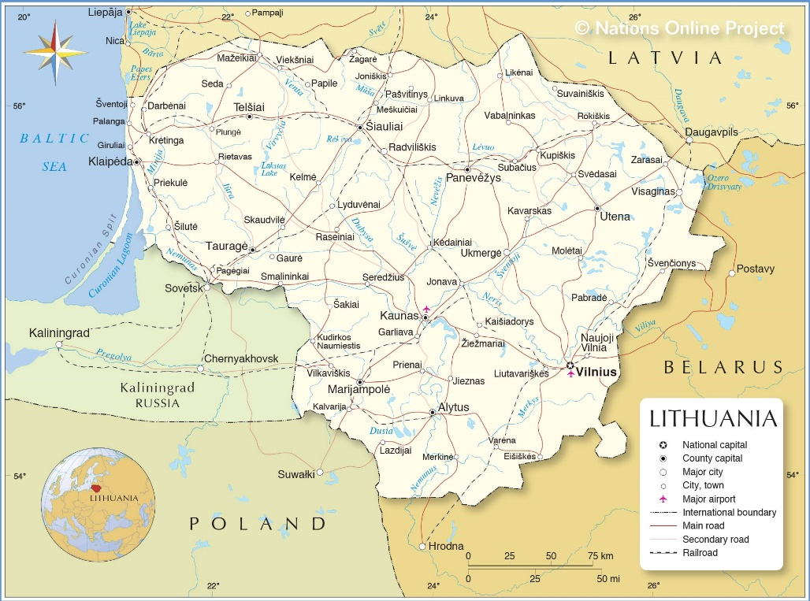

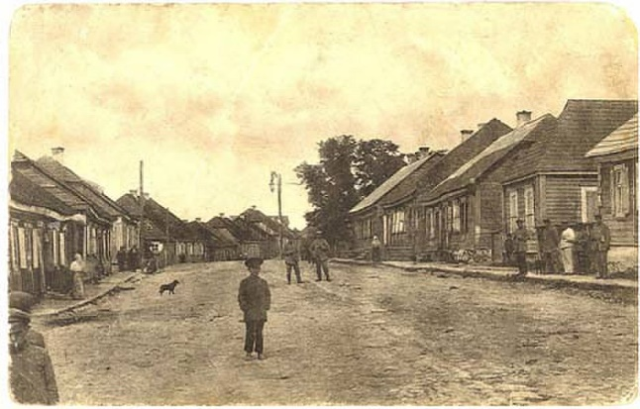

A street in Raseiniai [3]

Several members of the family told of their Lithuanian origins.

**Rokhel Luban states in her memoirs**[4] “*Mother told us that her grandfather and grandmother used to live in Kovno. In those times they used to snatch Jewish children to take them for soldiers. Many children were converted. The great-grandfather and great-grandmother took the children and came with them to the Ukraine*”.

Although not stated, her meaning was the province Kovno and not that city. She never mentioned Raseiniai to this author over many conversation in Israel.

**William Komisaruk**, Bronx, U.S.A in a letter to this author[5] in 1968 wrote: *“My great grandfather has four young boys. And so, he decided to come down from Russian Lithuania and settle in the district of Ekaterinoslav.”* William also did not mention the name of the town in Lithuania.

A source for the name of the town was the

1858 census[6] of Grafskoy, Jewish agricultural colony,

The second entry in the following page was the Komisaruk family.

Place of origin: ***“Belonged to the Rossiensky community”*** the town now called Raseiniai.

Men Women

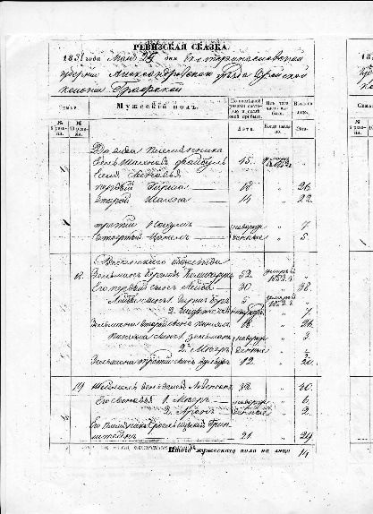 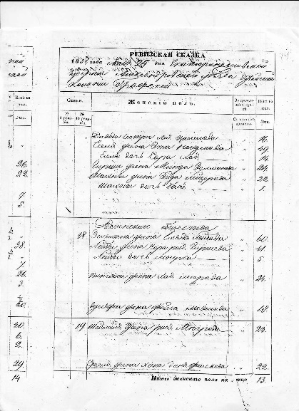

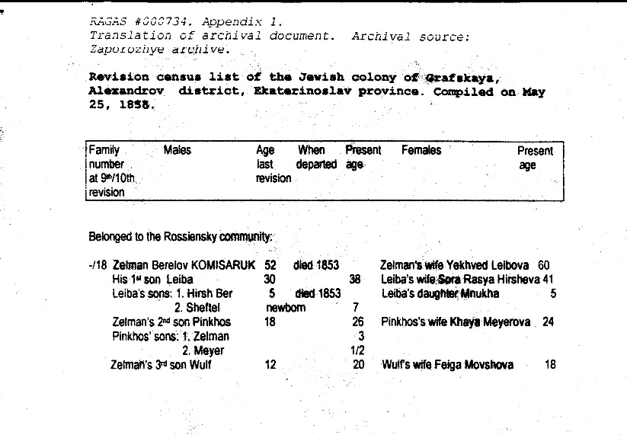

The head of the Komisaruk family was Zelman Berelov Komisaruk.

The inclusion of the Patronymic provides an earlier generation of the Komisaruk family Berel (in Hebrew Dov Ber)

The discovery of the book לקורות העיר ראסיין ורבניה “For the sources of the city Rasein and its Rabbis”, Moshe Markowitz, Warsaw 1913[7] provided records of the presence of the Komisaruk family in a short biography of rabbi Pinchas Komisaruk.

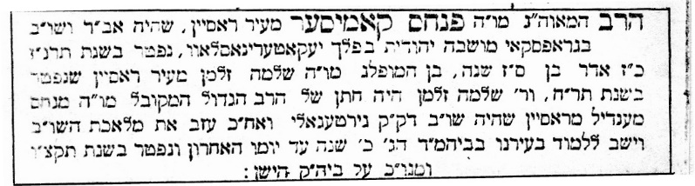

*"The rabbi, the great luminary, our teacher the Rabbi PINKHAS KOMISAR from the city of Rassein, who was Av Din and Shokhet in Grafskoy, a Jewish colony in the Government of Yekaterinoslav, died in the year 5657, (1897) 27th Adar, aged 67. Son of our outstanding teacher Rabbi Shlomo Zalman from the city of Rassein who died in the year 1848. Reb Shlomo Zalman was the son-in-law of the great Rabbi, the Kabbalist, our teacher Rabbi Menakhem Mendel from Rassein who was Shokhet in the Holy Community Girtegola and afterwards left the labour of Shekhita and sat learning in our city in the Great Beit Midrash 20 years until his last day and died in 5596 (1836). His honourable resting place is in the old cemetery."*

There are several errors in this information. Rabbi Shlomo Zalman did not die in 1848 but in 1853 in Grafskoy. The error may have been made by the author of "Ir Rassein" who found no further reference to Shlomo Zalman in Rassein after 1848, by which time he had emigrated from the city. His father-in-law was not Menakhem Mendel but Leib who may have been a son of Menakhem Mendel.

Rabbi Dov Ber and Ester Komisaruk were the common ancestors of three families: Komisaruk (Komesaroff), Zhmood and Grinblat, although the Grinblat family have yet to be identified in Lithuanian archival records.

Records where the name of Berel Komisaruk appears:

1784. Census of the Grand Duchy of Lithuanian[8] Rassein district, Girtagola village: appears Dawid Mejorowicz with three sons:

1. Leiba

2. Berel

3. Velvel

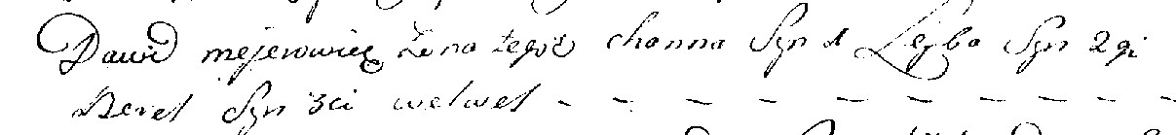

This record provides the name of two earlier ancestor: David the son of Meir, later called Komisaruk.

**The 1816 Revision List for Rassein city** includes two family groups with heads of family Leib, son of David Komisaruk and Velvel, son of David Komisaruk. Under the family group of Leib, who was missing in 1816, appears his brother Berel, son of David Komisaruk and his son Zalman.

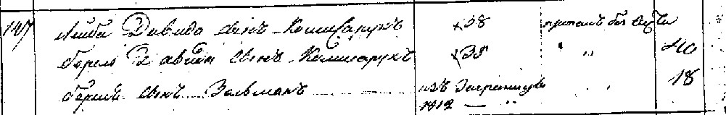

The order of the sons of David Komisaruk, provided by their age order, is identical with the above 1784 list, thus confirming that, although eighteenth century records predated the adoption of surnames by the Jews, their identity can be established by comparison with the configuration in a later census, 1816, where the same individuals appear with their surname Komisaruk.

Leiba aged 38 in 1811 (Missing in 1816), Berel aged 40 in 1816, Velvel aged 35 in 1816

**1845. tax appeal**

In 1845 Shlomo Zalmen appears as the fourth signatory out of forty-six in an appeal to the Tsarist authorities by the Jews of Rassein against the tax levy. This may indicate his position in the community hierarchy. The appeal was based on the fact that many of those listed as liable to pay tax were already dead, such as Shlomo Zalmen's father Berel who died in 1843.



**List of people who did not, or were not expected to pay their taxes**. The reason given in Berel's case was that he "died in 1843". The recording of his name "Berel Davidovitch Komisaruk" in this list facilitated bridging between earlier documents bearing that name and later ones referring to his son Zalmen as "Zalmen Berelovitch". Appears on the 1949 tax list with the same comments.

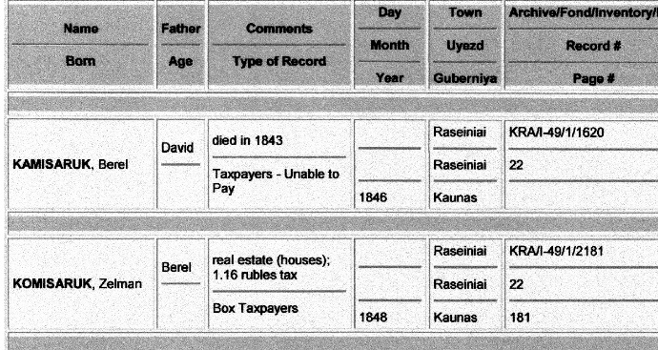

Zalman also appears in a rabbis Electors list in 1847 prior to his moving to the colonies in the Ukraine.

**1848. List of tax payers in Rassein** where Berel appears as the patronymic of his son "Zalmen Berelovitch Komisaruk".

**Komisaruk property in Raseiniai: Kloiz Chayei Adam:**

Further evidence of the Komisaruk family's involvement in religious and scholastic life in the Rassein community can be found in the records of the allocation of funds collected from the Jews in the Box Tax: In an article written by Anatoly Chayesh (Jewish historian living in St.Petersburg) on the subject of the collection and application of the "Box Tax" in the Russian Tsarist Empire. [9]

“On the 25th of August in the year 1850, item 12580, a Kloiz on the yard of the property of the Jew Komisaruk, called Chayei Adam"

а) от 25 августа 1850 г. за · 12580 на плацу еврея ***Комисарука***, под названием "Хаи Адам";



From this information we can learn that the Komisaruk family operated a "Beit Midrash" or Kloiz (a place of learning and prayer) on its own property. This may explain why in the records of the 1848 Box Tax there are two entries for the payment by Berel Komisaruk's son Zalmen, one larger payment probably for his house and another smaller payment probably for the property of the Kloiz. The name given to the Beit Midrash "Khayei Adam" was the name of a book written by Rabbi Avraham Danzig, the father of Berel Komisaruk's brother-in-law Yitskhak Danzig of Vilna. Danzig’s son Yitskhak married Gittel a daughter of Rabbi Yehudah Leib of Serhei, the second son of the Vilna Gaon. Gittel’s sister was Ester the wife of Berel Komisaruk. Thus was established the relationship of the Komisaruk family with the Vilna Gaon.

The Kloiz was still operating in Raseiniai, at least in 1936, as mentioned in “Raseiniai Region Jews, Their Lives and Fates”, Lina Lantautiene , Raseiniai 2018[10]. It was probably destroyed by the Nazis and local Lithuanians during the Holocaust together with the Jewish cemeteries and synagogues. If it were possible to locate the site of the Kloiz, we would know where the Komisaruks lived . The Raseiniai Museum was contacted and the author of the above book was unable to locate it.



**Shlomo Zalmen appears in a list of property owners in Rassein in 1846 who housed Cheders.** There were three entries for "Zelman Komiseruk" (sic) for three Melamdim whose Cheders he housed. This may mean that he owned three properties or that he had a large house which had the space to house three Cheders. The teachers in these Cheders were Yudel Tapuah, Girsh Girago and Mortkhel Zegar.

In 1847 Rabbi Shlomo-Zalmen joined a group of eleven families from Rassein which applied to take up the offer of Tsar Nicholas the First to settle on the land in the south-eastern Ukraine.

1**847/8.Lists of Rassein Jews who applied and were approved to become farmers in Novorussia (south-east Ukraine)**

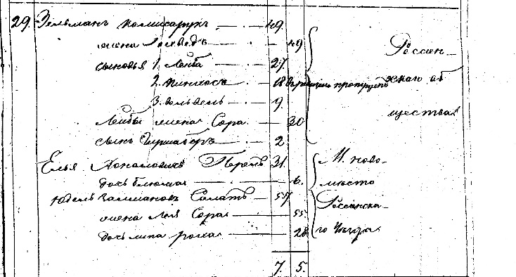

#29 Zelman Komisaruk 49

His wife Yokhved 49

Sons 1. Leiba 27

2. Pinkhas 18

3. Velvel 9

Leiba’s wife Sora 30

Son Girsh Ber 2

(others are not related).

Grouped as Rossin community.

In 1848 the Komisaruk family settled in the Colony Grafskoy (now known as Prolotarsky), in the district of Mariupol in the Gubernia (Government or province) Yekaterinoslav, now called Dnyepropetrovsk. Shlomo-Zalamen did not live long and passed away in 1853, probably from disease which took the lives of about 50% of the early settlers in all the seventeen colonies.

Shlomo-Zalman’s property as given to him by the authorities comprise 30[11] Desyatins.

On heath each of his three sons Leib, Pinkhas and Velvel inherited 10 desyatins. Their brother Yankel who remained in Raseiniai received no share of the property which later caused a family feud.

Shlomo-Zalman was buried in a prominent position[12] at the front of the Grafskoy cemetery and in 1897 his son rabbi Pinkhas was buried nearby . The cemetery was destroyed in the 1950’s by the local Ukrainians who took over the colony after the Nazis murdered all the Jews who remained in the colonies.

Members of the Komisaruk family who remained in Raseiniai included Rabbi Shlomo-Zalman’s son Yankel who had been left there to manage the family property and the descendants of Velvel son of David, the original Komisaruk. Members of this family moved to France and several perished in the Holocaust. A current contact has been established between this author and Geraldine (Tsipora) Trom in Belgium and the family relationship was confirmed by DNA testing.

Former Grafskoy synagogue in ruins, 2020[13]

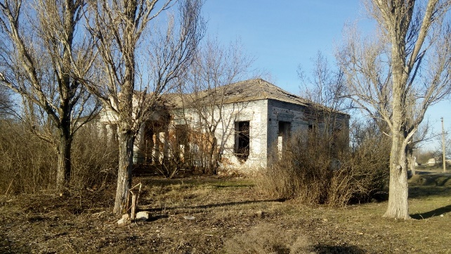 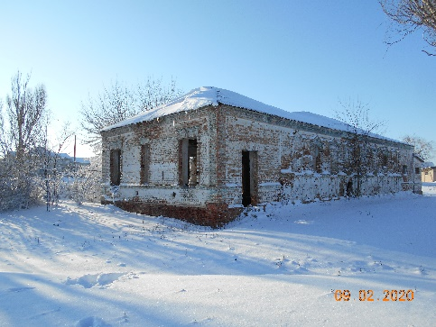

1. i <http://kehilalinks.jewishgen.org/Colonies_of_Ukraine/>
2. <https://kehilalinks.jewishgen.ord/Raseiniai/History.html>
3. “Raseiniai Region Jews, Their Lives and Fates”, Lina Lantautiene , Raseiniai 2018

   <https://www.dropbox.com/s/s94ks4z3hylzybt/Raseiniai-JEWS.pdf?dl=0>
4. <https://kehilalinks.jewishgen.org/Colonies_of_Ukraine/memoirs_of_rokhel_luban.htm>
5. Collection of correspondence between Chaim Freedman and a number of relatives in the U.S.A and Canada provide a wealth of information in the 1960’s and 1970’s.
6. The Zaporozhe archive visited by Mel Comisarow in 1999 where he commissioned research of families who lived on several colonies. Considerable material was provide by the archive.
7. <https://www.hebrewbooks.org/36786>

   The book was discovered by Chaim Freedman while examining community history books in a library attached to Beit Hatfutzot Nuseum in tel Aviv. He had no idea that the book held the origins of the family in Raseiniai until, flicking though the book, his eyes suddenly say the name of his Great-Great-Grandfather “Pinkhas Komisar”.
8. Jewish Family History Foundation, Eighteenth century records, Sonya and the late David Hoffman.

   http://www.jewishfamily history.org/

   ix "Box Tax Paperwork Records as a Source of Information About the Life of Jewish Communities and Their Personal Structure"
9.
10. “Raseiniai Region Jews, Their Lives and Fates”, Lina Lantautiene, Raseiniai 2018.

    <https://www.dropbox.com/s/s94ks4z3hylzybt/Raseiniai-JEWS.pdf?dl=0>
11. Desyatin = 1.09 Hecters, 2.7 acres, 10 Dunams.
12. William Komesaroff, Melbourne, recalled the site of his family’s graves in the Grafskoy cemetery
13. Irina Nosova, a current resident of Prolotarsky, correrspondence with Chaim Freedman.